Exoplanet Observations Reveal Early Ingress

James Carlisle^{1,4}, Cindy Foote², Thomas Smith³,
Jolyon Johnson⁴, and Russell Genet^{4,5}

1. Hill House Observatory, Atascadero, CA 2. Vermillion Cliffs Observatory, UT
3. Dark Ridge Observatory, Weed, NM 4. Cuesta College, San Luis Obispo, CA
5. California Polytechnic State University, San Luis Obispo, CA

Abstract Using differential photometry, a transit of exoplanet WASP-1b was simultaneously observed from three western states. Analysis of the observations revealed that the ingress occurred 0.018d (~25.9 minutes) earlier than predicted. The early ingress could be due to a still imprecise ephemeris or, perhaps, to the gravitational influence of a second planet.

Introduction

The WASP-1b project was part of a fall 2007 research seminar at Cuesta College led by Genet. The purpose of the project was, from differential photometric light curves of the transiting exoplanet WASP-1b, to obtain times of ingress and egress.
Ingress is the midpoint between first and second contacts. First contact is defined as the moment that the leading edge of the planet first touches the limb of the star. Second contact is when the following edge of the planet touches the limb of the star. Egress is given as the midpoint between third and fourth contacts. Third contact is defined as the moment the leading edge of the planet crosses the opposite limb of the star. Fourth contact is when the following edge of the planet crosses the same limb of the star as in third contact.
As mentioned in The Extrasolar Planets Encyclopedia (Schneider 2008) WASP-1b (GSC 02265-00107) was discovered by Collier-Cameron et al. on September 25, 2006. This planet orbits an F7V type star with an apparent V magnitude of 11.79. The mass of this star is 1.24 ±0.17 M_{Sun} with a radius of 1.382 ± 0.1 R_{Sun}. Epoch 2008 coordinates of this star are: RA 00h 20m 40s, DEC +31° 59m 24s. The planet, WASP-1b, has a radius of 1.358 ± 0.1 R_{Jupiter} with an orbital period of 2.51997 ± 0.00016 days. WASP-1b’s mass is 0.89 ± 0.2 M_{Jupiter} and the semi major axis is 0.0382 ± 0.0013 AU with an inclination of 83.9 ± 6.1°.

Observatories and Equipment

Carlisle, a member of the Cuesta College research seminar, observed from Hill House Observatory in Atascadero, California. He used a fourteen inch Meade RCX400 with an SBIG ST402 ME unfiltered CCD camera. With a Meade field flattener/focal reducer, the system was f/4. The telescope and guide camera were controlled by MPO Connections.
Foote, at Vermillion Cliffs Observatory in Kanab, Utah, used a ScopeCraft SC-2438 twenty-four inch, f/3.5 prime focus telescope equipped with an SBIG ST-8e CCD camera. MPO Connections was used to operate the telescope with an internal guide chip in the CCD camera.
Smith, at Dark Ridge Observatory in Weed, New Mexico, used a Meade fourteen inch LX200GPS telescope with an SBIG ST-8XME CCD camera equipped with a focal reducer for an overall f/4 optical system. CCDSoft was used to control the telescope and guide camera.

Observations

Three light curves of the same transit of WASP-1b were obtained simultaneously from three different observatories located in three different western states (California, Utah, and New Mexico). Carlisle observed WASP-1b unfiltered with twenty second integrations. Carlisle’s observations (Figure 1) had an overall photometric precision, using the standard deviation of the comparison star minus the check star (C-K) values, of 6.9 milli-magnitudes.

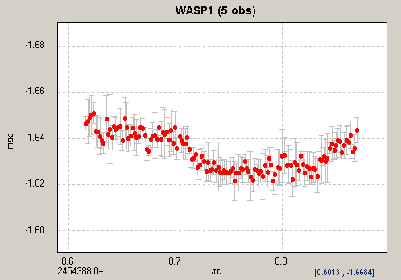

Figure 1: Each data point in the above plot of Carlisle’s data represents non-overlapping averages of five unbinned data points.

Foote’s integration times were 30 seconds in the Rc band. The overall photometric precision of Foote’s data (Figure 2) using the standard deviation of C-K values, was 6.0 milli-magnitudes.

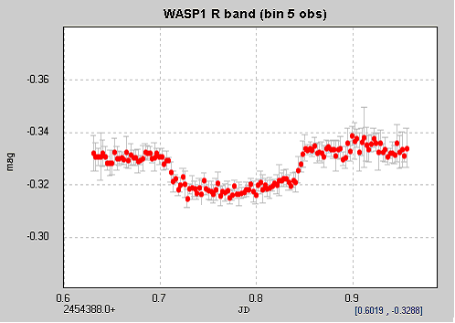

Figure 2: Each data point in the above plot showing Foote’s data represents five binned averages from 671 unbinned data points.

Smith used an Rc filter and 45 second integrations. The photometric precision of Smith’s data (Figure 3), using the standard deviation of C-K values was 5.4 milli-magnitudes.

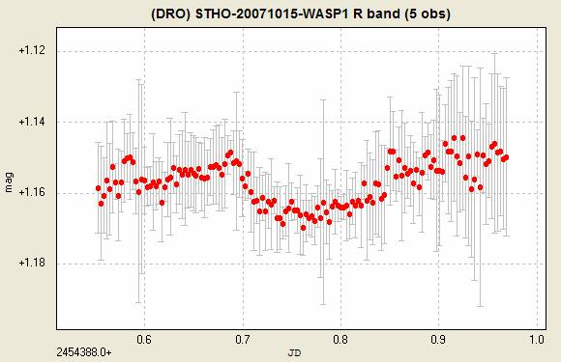
Figure 3: Each data point in the above plot showing Smith’s data represents non-overlapping averages of five unbinned data points.

Data Reductions and Analysis

AIP4WIN (Berry and Burnell 2006) was used to reduce Carlisle’s and Foote’s observations, while CCDSoft was used to reduce Smith’s observations, including subtracting darks and dividing flats. Peranso was used to generate all three light curves. MS Paint was used to draw straight line segments for the data analysis.
Using Carlisle, Foote, and Smiths’ data, Johnson digitally (MS Paint) estimated the first and second contacts using three straight line segments that best fit the average slope before first contact, between first and second contact, and between the second and third contacts. The points where these lines intersected were recorded as the first and second points of contact. Ingress was determined as the average of first and second contacts.
These estimates were made in a systematic manner. First, three straight line segments were drawn with MS Paint on each light curve so that there were nearly equal points above and below each line segment. A scale to the nearest 0.001d (~1.4 minutes) was added by counting the number of pixels between the lines of 0.6d and 0.8d and dividing by ten and magnifying the image eight times. A magnified ingress portion of Carlisle’s data is shown in Figure 4 as an example. Table 1 shows the estimated contact times for all three light curves.

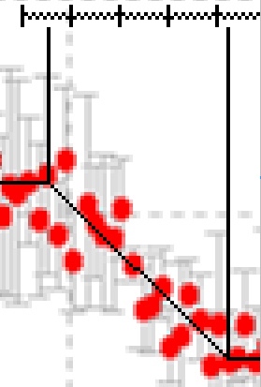

Figure 4: The above ingress plot is a portion of Carlisle’s data magnified 6 times. All three light curves were magnified in this manner to estimate all the points of contact.

Observer | First Contact (JD) | Second Contact (JD)
Carlisle | 0.694 | 0.732
Foote | 0.701 | 0.737
Smith | 0.694 | 0.712

Table 1: Estimated points of contact for data from Carlisle, Foote, and Smith.

Errors were calculated by finding the average difference between the first and second estimated contact times for all three light curves. The error estimate for second contact including Smith’s data was a very large 0.010d, but it was a more reasonable 0.0025d without it. Thus, Smith’s estimated first and second contact points were not used in the final analysis.

Conclusions

The predicted ingress for WASP-1b was JD 2454388.731 (Castillano, 2007). The observed ingress occurred at JD 2454388.711 ± 0.003. This is 0.020d (~28.8 minutes) earlier than predicted, 6.7 times our estimated error of only 0.003d (~4.3 minutes). Egress, which was predicted to be JD 2454388.851 (Castillano, 2007), appears to have occurred early as well, but the data set does not allow for a precise egress estimate.
One explanation for the early transit may simply be that the exoplanet’s ephemeris is not well known. A more interesting explanation for this earlier than predicted transit is that another, as yet undetected planet, is affecting the transit timing. A primary reason for obtaining transit times of already discovered exoplanets is, of course, to discover additional planets.

References

Berry, Richard, and Burnell, James. The Handbook of Astronomical Image Processing, Edition 2.0. Richmond, VA: Willmann-Bell, 2006.
Cameron, Collie. et al. WASP-1b and WASP-2b: Two new transiting exoplanets detected with SuperWASP and SOPHIE. Monthly Notices of the Royal Astronomical Society 375 March (2007): 951-957.
Castillano, Tim. 2007. www.TransitSearch.org
Schneider, Jean. The Extrasolar Planets Encyclopedia. March, 27 2008. Paris Observatory. http://ad.usno.navy.mil/wds/wds.html

