A Compact, Off-the-Shelf, Low-Cost Dual Channel Photometer

Thomas C. Smith
Dark Ridge Observatory
5456 Bolsa Road, Atascadero, CA 93422
tcsmith@tcsn.net

Russell M. Genet
Orion Observatory
4995 Santa Margarita Lake Road, Santa Margarita, CA 93453
russmgenet@aol.com

Christine L. Heather
Physics Department
California Polytechnic State University, San Luis Obispo, CA 93407
cheather@calpoly.edu

Abstract

Photometric observations of short-period variable stars are time constrained because each basic observational sequence must be completed before the variable significantly changes its magnitude or color. A choice must be made. Should the scarce time within a sequence time be devoted to making several observations in the same color band that, when combined will significantly improve photometric precision over that of a single observation, or should the single observations be spread sequentially across color bands to provide both magnitude and color, thus enhancing astrophysical interpretations? A third alternative has occasionally been employed for many years; making a sequence of simultaneous observations in two or more color bands by using a dichroic beam splitter to partition the light into separate color bands with a separate detector being devoted to each band. The two-channel CCD photometer we describe can be operated in the Johnson-Cousins V and I_{c} bands simultaneously (or alternatively in B and R_{c}). The compact photometer, which can be assembled from off-the-shelf, low-cost components, utilizes a dichroic beam splitter (for V and I_{c}), a Meade flip mirror system, and two SBIG CCD cameras. Our preliminary results suggest that this doubling of observations has been obtained without any sacrifice in photometric precision. © Society for Astronomical Science.

1. Overcoming the Limits of Time-Constrained Photometry

It has been amply demonstrated that multi-color photometry with sub-millimagnitude precision can be achieved with small-aperture telescopes equipped with sequential filters if the observed stars are non-variable or are slowly varying. One beats down the photon and scintillation noise inherent in small-telescope observations via extended observations in each color band.
Photometric observations of short-period variable stars however, are time constrained because each basic observational sequence must be completed before the variable significantly changes its magnitude or color. Should the scarce within-sequence time be devoted to making several observations in the same color band which, when combined, will significantly improve photometric precision over that of a single observation, or should the single observations be made sequentially in two or more different color bands to bolster astrophysical significance? Rather than choosing between these alternatives, one can use dichroic beam splitters to partition incoming photons into two or more different wavelength bands which can be observed simultaneously.
Besides observing two or more colors without reducing the number of observations in a color band, another distinct advantage of simultaneous color observations over sequential observations is that the derived color differences (such as V - I_{c}) are more precise when taken simultaneously as opposed to sequentially because atmospheric changes should affect color bands similarly and thus subtract out when one takes the color difference. Fully realizing this benefit, however, requires true simultaneity, i.e. the integrations must begin together and be of the same length.
Over the years, a number of multi-channel photometers have gathered useful data. These include the two-channel photomultiplier system by Geyer and Hoffmann (1975), the Bonn University Simultaneous Camera (BUSCA) described by Reif et al (1998), the University of Tokyo’s 15-channel system (Doi et al 1998), and the four-channel high-speed CCD ULTRACAM photometer (Dihillon and Marsh 2001).
In spite of their successful use over the years, simultaneous multi-channel CCD photometers remain rare for three good reasons. First, the costs of multiple CCD cameras (one for each channel), the dichroic filters, and the housing are significantly greater than the cost of a single CCD camera equipped with a sequential filter wheel. Second, multiple CCD cameras and dichroic filters obviously take up more space than a single camera/filter-wheel combination. This can be a serious problem with smaller telescopes, such as the compact Schmidt-Cass fork-mounted go-to systems. Finally, one could not purchase—off-the-shelf—compact, low-cost multi-channel systems. This has been a serious impediment to their wide spread use.
The Johnson-Cousins system has been widely used for decades, and employs low-cost, sturdy glass filters. Because the Johnson-Cousins bands significantly overlap each other, a dual-channel system that employs a dichroic beamsplitter to separate the incoming light into two color bands cannot use adjacent bands. Traditionally, magnitudes have been primarily reported in V, while color differences have been variously reported as B-V, V-R_{c}, V-I_{c}, etc. Although there is considerable merit in observing in three or even more color bands, many of the benefits of multi-color observations can be obtained by observing in just two bands, providing both a magnitude and a color difference (a significant improvement over providing a magnitude alone). For precise, time-constrained photometry of fast-changing variable stars, a simultaneous two-color photometer may be a good compromise between the number of color bands and cost and space. As CCD cameras are most sensitive in V, R_{c}, and I_{c}, V magnitudes combined with a V-I_{c} color may, for a dual-channel photometer, provide the widest wavelength baseline consistent with good detector quantum efficiency.

2. An Off-the-Shelf Low-Cost Dual-Channel Photometer

Our system utilizes an off-the-shelf, $50 Edmund Industrial Optics 50x50mm dichroic beam splitter with a crossover at about 660 nm which, as luck would have it, happens to be near middle of the R_{c} band, with most (but not quite all) of the V long-wavelength tail to one side, and the entire I_{c} short-wavelength tail to the other—well suited, albeit not perfect, for a V and I_{c} two-channel system. For about $500, Custom Scientific, in Phoenix, Arizona, can provide 50x50mm dichroic beam splitters at any specified wavelength, such as 700nm, which would be slightly preferable although more expensive. We were initially concerned that the advertised surface quality of the Edmund beamsplitter (2 wavelengths) might be inadequate, but image degradation did not turn out to be significant.
The optical-mechanical interface for our test two-channel system needed to: (1) firmly attach to our compact Schmidt-Cass telescope, (2) hold our dichroic beamsplitter at 45 degrees (with fine adjustments in both axis so the centers of the two cameras’ fields-of-view could be made to coincide), and (3) firmly support our two SBIG cameras (along with any focal reducers inserted in the optical path). The low-cost, off-the-shelf Meade Model 647 Flip-Mirror System (2”) admirably performed all three functions. We simply replaced the mirror that came with the system with the Edmund dichroic beam splitter. The fine adjustments on the Meade system were invaluable.
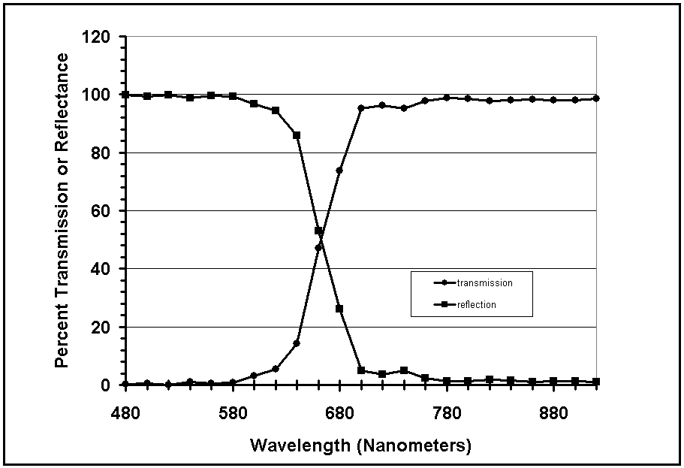

Figure 1. Transmission and reflectance curves for the low-cost Edmund Industrial dichroic beam splitter. These curves are based on data supplied by the manufacturer. One of us (Heather) performed independent spectrophotometer tests of this filter.

To evaluate our dual-channel concept, we temporarily utilized the Dark Ridge Observatory’s SBIG ST7XE CCD camera, and the Orion Observatory’s ST8XE CCD camera. We incorporated both cameras in our test dual-channel system on Dark Ridge’s 14-inch Meade LX-200GPS telescope. We purchased an additional CCD camera for each observatory so we can have a dual-channel system operating at each observatory. Since these “second” cameras need neither autoguiding nor motorized filter wheels, we utilized the newly available, low cost, smaller-sized SGIB 402 CCD cameras (with CCD chips chosen to match our current cameras).

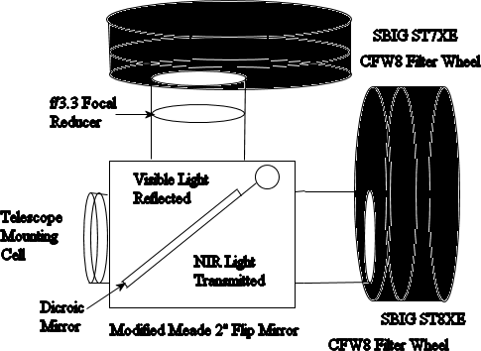

Figure 2. Our initial test configuration used an SBIG ST7 camera (V filter) with an f/6.3 focal reducer and an SBIG ST8 camera (I_{c}) filter without any focal reduction. Both were attached to a Meade Flip Mirror System (mirror replaced with an Edmund Industrial dichroic beamsplitter) which, in turn, was attached to the Dark Ridge Observatory’s 14-inch f/10 Meade LX200GPS Schmidt-Cass telescope. Our two operational configurations will be similar except one of the cameras has been replaced, in each case, with the lower cost, smaller SBIG ST402 camera (without an autoguiding chip or filter wheel).

To control our CCD cameras, we used two instances, in separate memory spaces, of Software Bisque’s CCD camera control software, CCD Soft. We did not experience any difficulties controlling two cameras—one with an autoguiding chip.
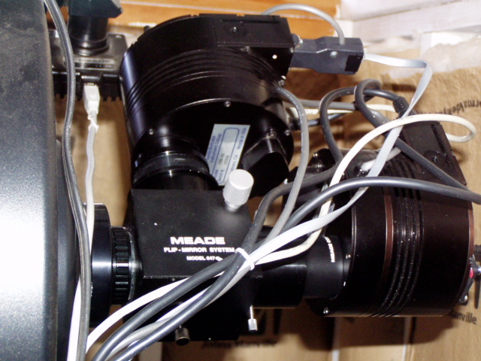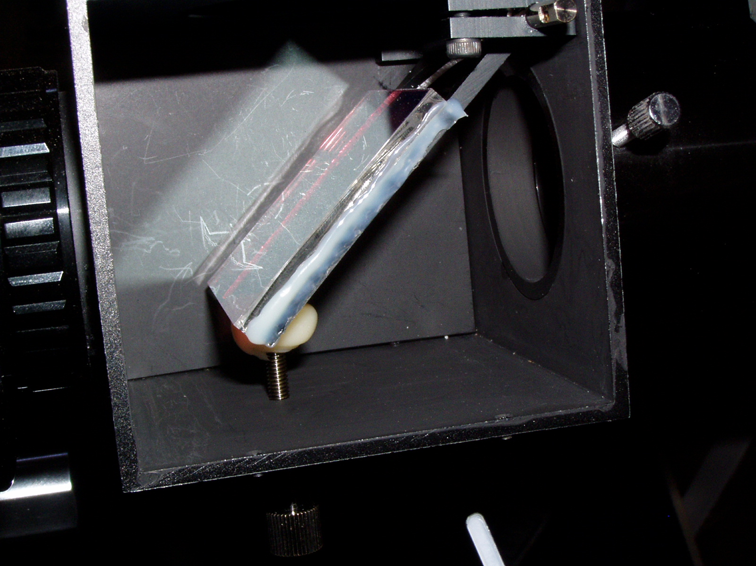

Figure 3. An overview of the two-channel test-photometer is shown on the left. The Meade 14-inch LX-200GPS telescope is on the far left. Coupled directly to it is the Meade 2” flip mirror system. The f/6.3 focal reducer and SBIG ST7XE camera and filter wheel are shown in the upper middle, while the SBIG ST8XE camera and filter wheel are shown on the right. The photograph on the right shows the Edmund Industrial dichroic filter which replaced the mirror in the Meade flip mirror system (with the system’s side cover removed).

2. Initial Results

Prior to the initial operation of our two-channel photometer, we had been observing the short-period W UMa-type binary V1191 Cyg. All our observations were made in R_{c}. We continued our observations of V1191 Cyg with our test dual-channel system, making nearly (although not exactly) simultaneous observations in V and I_{c}. We have not yet addressed questions of synchronization. Shown below is a recent one-channel R_{c} light curve and, taken some two weeks later, simultaneous V and I_{c} light curves obtained with our test dual-channel system.

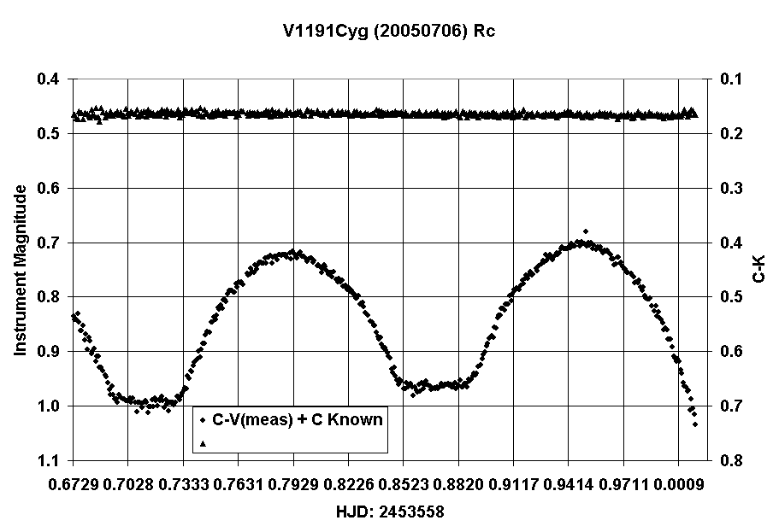

Figure 4. Observations of V1191 Cyg with a single-channel photometer in R_{c} (bottom curve) made at the Dark Ridge Observatory using an SBIG ST7XE camera with 90 second integrations. The precision of the observations, as suggested by the one-sigma standard deviation of the comparison-check observations (top curve) over the entire night was 3.7 millimagnitudes.

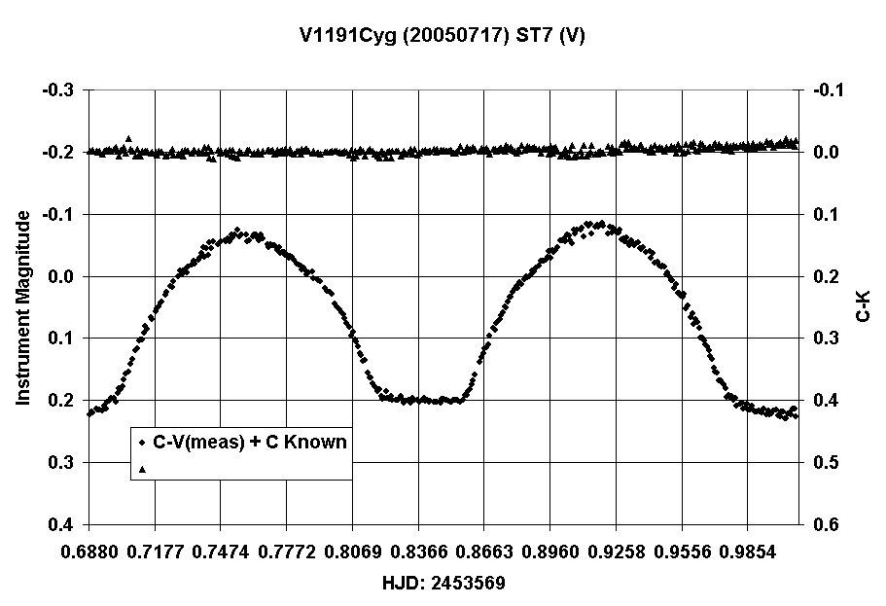

Figure 5. V-band observations from the two-channel photometer of 1191 Cyg. Integrations were 60 seconds (as opposed to 90 seconds for the observations shown in Figure 4. The overall standard deviation for the night (top curve) was 5.7 millimagnitudes.

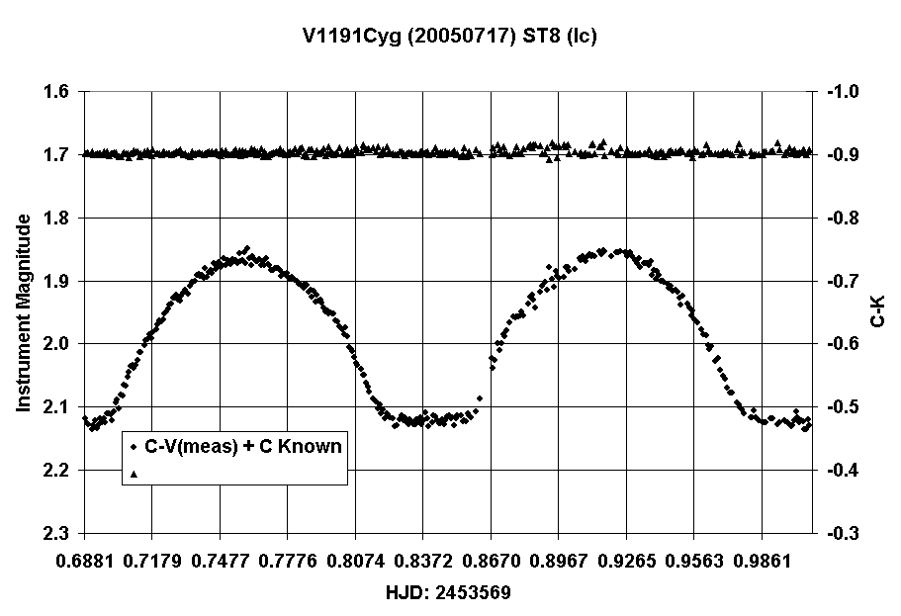

Figure 6. I_{c}-band observations from the two-channel photometer of 1191 Cyg. Integrations were 60 seconds. The overall standard deviation for the night (top curve comparison - check) was 4.6 millimagnitudes.

4. Conclusions

Photometric observations of fast-changing variable stars, such as the W UMa eclipsing binaries we observe, are time constrained. One way of overcoming such time constraints is to make simultaneous photometric observations in two color bands using a dichroic beam splitter to partition the light. We devised and evaluated a two-channel photometer assembled from low-cost off-the-shelf components. We concluded that our two-channel system worked as well as our somewhat similar one-channel system while providing twice the data.

5. Acknowledgements

We are pleased to acknowledge helpful suggestions by Arne Henden, Kenneth Kissell, John Percy, and Dirk Terrell.

6. References

Geyer, E.H., and M. Hoffmann. 1975. “A Double Beam Photoelectric Photometer for Astronomical Applications.” Astron. Astrophys. 38, 359-362.

Reif, K., K. Bagschik, G. Klink, R. Kohley, H. Poschmann, K.S. de Boer, P. Mueller, U. Mebold, J. Schmoll, and U. Heber. 1998. “BUSCA: Simultaneous Imaging in Four Optical Bands.” Astronomische Gesellschaft Meeting Abstracts, Heidelberg.

Doi, M., H Furusawa, N. Fumiaki, S. Okamura, M. Sekiguchi, K Shimasaku, and N. Takeyama. 1998. “UT 15-Color Dichroic-Mirror Camera and Future Prospects.” Proc. SPIE, 3355, 646-657.

Dhillon, V., and T. Marsh. 2001. “ULTRACAM—Studying Astrophysics on the Fastest Timescales.” New Astronomy Reviews, 45, 91-95.

